1. What is the MAC address from your computer?

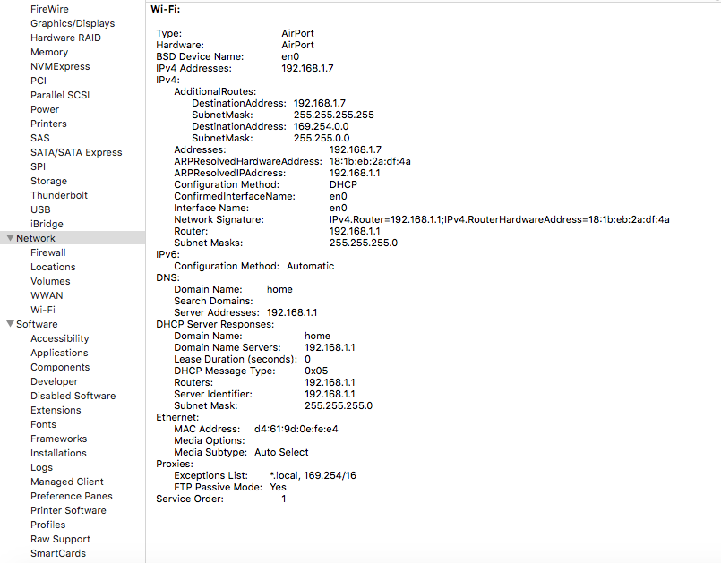

MAC Address of my computer is d4:61:9d:0e:fe:e4

1. What is the destination MAC address?

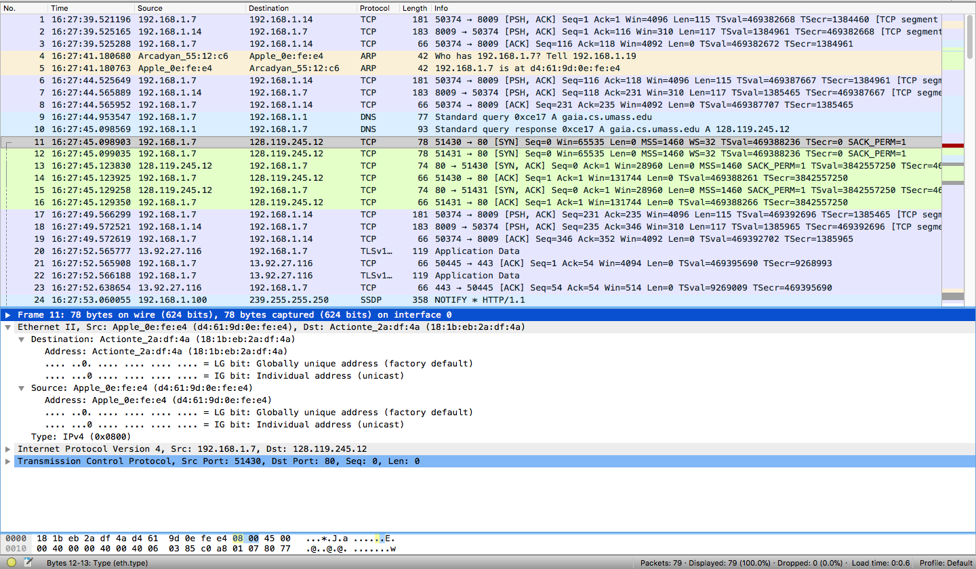

MAC address of destination is 18:1b:eb:2a:df:4a

1. What device has the MAC address shown in the destination?

Actiontec Electronics

1. Explain the relationship between the destination MAC address and the destination IP address.

* The MAC address is used ‘locally” to get frame from one interface to another physically-connected interface (same network, in IP-addressing sense.

1. Using the terminal (Cmd in Windows, Terminal in mac), run a command to display your full ARP list table. (Find out what the command is, and print a full screen shot of your result.)

